

KING’S OWN INSTITUTE*
Success in Higher Education

INDIVIDUAL ASSIGNMENT COVERSHEET

Family Name: Given Name:
Student Number: Lecturer’s/ Tutor`s Name:

Subject Code & Name:
Assignment Title:
Declaration
(This declaration must be completed by the student, or the assignment will not be marked.)

I certify the following:
- I have read and understood the Student Academic Misconduct Policy.
- This assignment is my own work based on my personal study and or research.
- I have acknowledged all material and sources used in the preparation of this assignment including any material generated in the course of my employment.
- The assignment has not previously been submitted for assessment.
- I have not copied in part or in whole or otherwise plagiarised the work of other students.
- I have read and understand the criteria used for assessment.
- The assignment is within the word and page limits specified in the unit outline.
- The use of any material in this assignment does not infringe the intellectual property / copyright of a third party.
- I understand that this assignment may undergo electronic detection for plagiarism, and an anonymous copy of the assignment may be retained on the database and used to make comparisons with other assignments in future.
- By completing this coversheet in full and submitting this assignment electronically, I am bound by the conditions of the KOI’s Student Academic Misconduct Policy and the declaration on this coversheet.

/ /

Signature Date

Assignment Receipt

Family Name: Given Name:

Student Number: Lecturer’s/ Tutor`s Name:

Subject Code & Name:

Assignment Title:

/ /

Signature Date

Critical Analysis Report: Daraz Ecommerce Website

1. Introduction
Daraz is now a top online shop hub in South Asia, with work in Bangladesh, Pakistan, Nepal, Sri Lanka, and Myanmar. It acts as a web place for buyers and sellers to meet. It started in 2012 and then joined the Alibaba Group in 2018. This move made its tech, delivery, and business range much stronger.
Daraz is primarily operated based on a B2C (Business-to-Consumer) model, where thousands of sellers display their products online and millions of buyers can easily buy those products. The platform offers products in various categories electronics, fashion, beauty products, home appliances, groceries, lifestyle accessories, etc.
Not only delivering products, Daraz also provides fast delivery services through its own Daraz Express (DEX) and has made multiple digital payment options available to users. In addition, regular big sale campaigns such as 11.11 Sale and 12.12 Sale generate a huge response among millions of buyers.
This website and mobile app are designed to provide easy navigation, product search, filtering, order tracking, and secure transactions. As a big platform, it does have some drawbacks, though, like overzealous advertising, occasionally inconsistent designs, and restrictions on product comparison. Because of this, the website of Daraz is regarded as more than just an online store; rather, it is a component of a digital experience in which user satisfaction is greatly influenced by interface design.
2. Website Structure
The homepage of the Daraz website acts as the primary entry point, and the site is organized hierarchically. Links to product categories, a navigation menu, promotional banners, and a search bar are all included on the homepage. Users can then access particular category pages, which are further subdivided into numerous subcategories. The user is directed to the relevant product listing page from each subcategory page, which then leads to the particular product detail page. Products can be added straight to the cart from the product detail page, which also offers product photos, descriptions, prices, seller details, and reviews. The Cart Page → Checkout → Payment Confirmation process is then followed step-by-step.
There is also a user account section, where buyers can manage order history, delivery tracking, Wishlist’s, and profile settings.

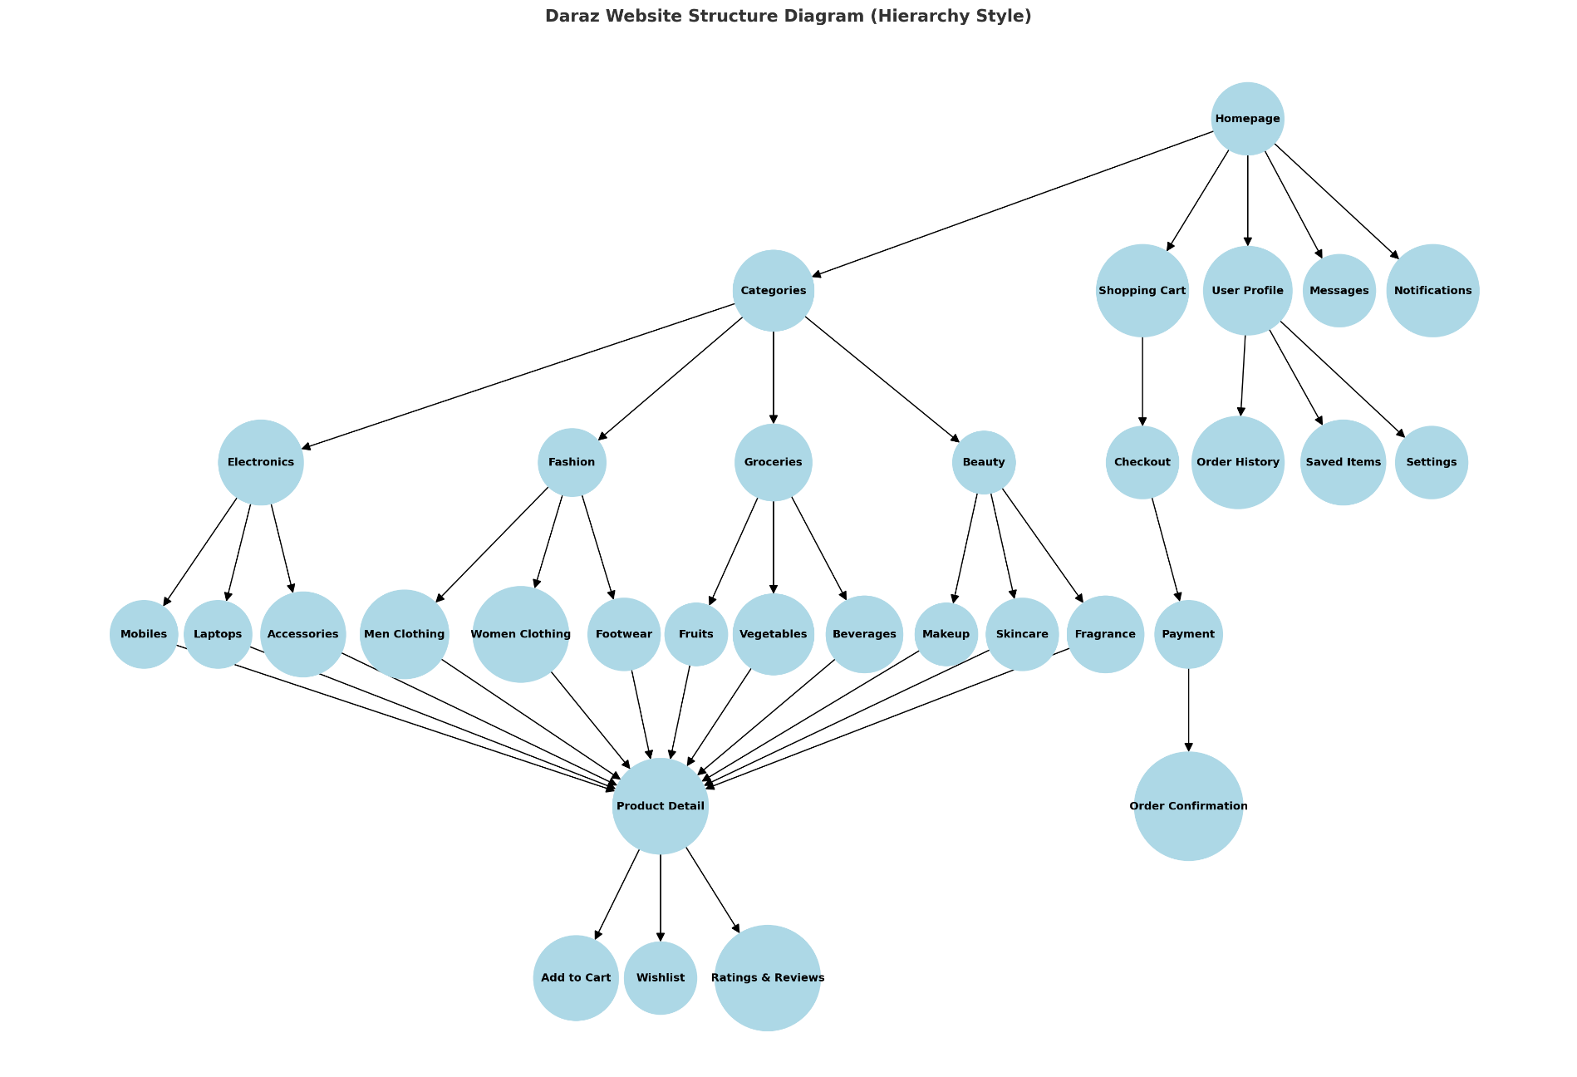
Daraz Website Structure Diagram

3. Analysis Based on Shneiderman’s Eight Golden Rules
Shneiderman's Eight Golden Rules of Interface Design provide an effective framework for analyzing the interface design of the Daraz website. Here, six principles are selected and explained based on screenshots.

3.1 Strive for Consistency
Homepage navigation bar and category menu

Daraz uses similar colors, fonts, and layouts to make it easy for users to recognize. The categories in the navigation bar are also well-organized. Homogeneous visual elements bring stability to the user experience.

3.2 Informative Feedback
Order Tracking Page
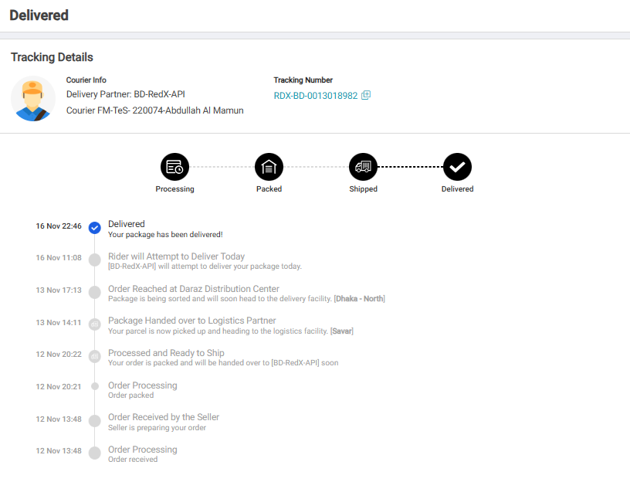

Users receive clear updates at every step (Placed → Shipped → Delivered) after placing an order. This increases trust and control

3.3 Permit Easy Reversal of Actions
Remove button on the cart page

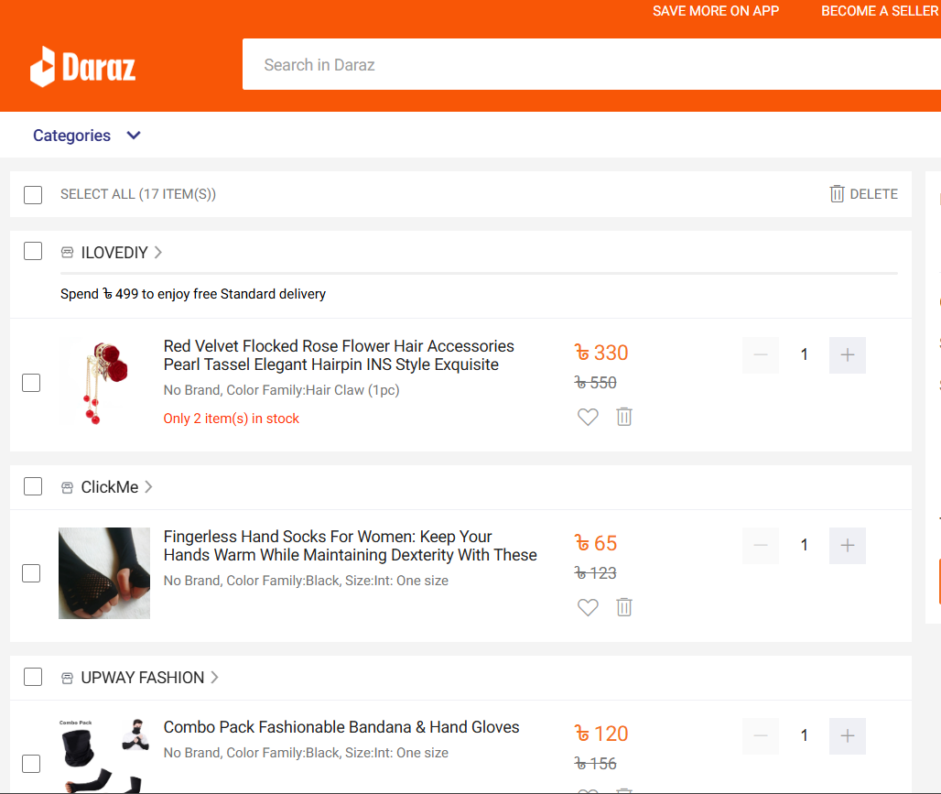

Users can easily remove products from the cart, but the return process is relatively complicated.

3.4 Prevent Errors
Login form validation

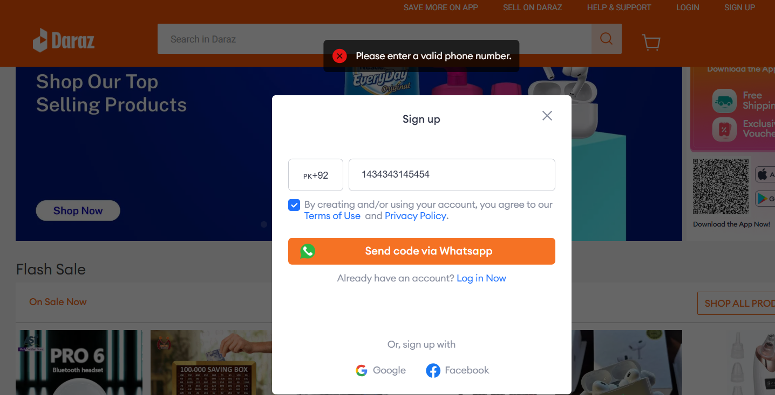

The system immediately warns if an incorrect email or mobile number is entered, which prevents mistakes. However, accurate information in product descriptions is not always guaranteed.

3.5 Support internal locus of control
Product Filter Section

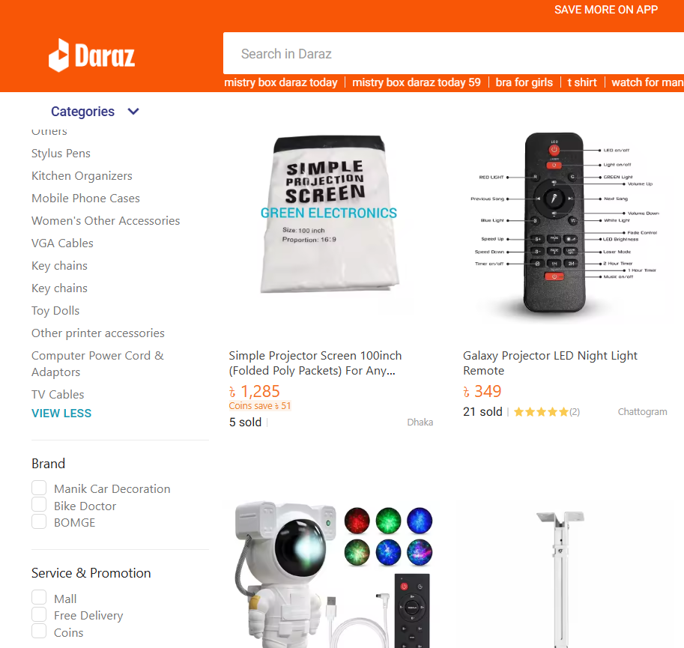

Users can filter products based on price, brand, rating, etc. The use of filters increases the user's freedom of decision-making.

3.6 Reduce Short-Term Memory Load
Search suggestions ensure quick access
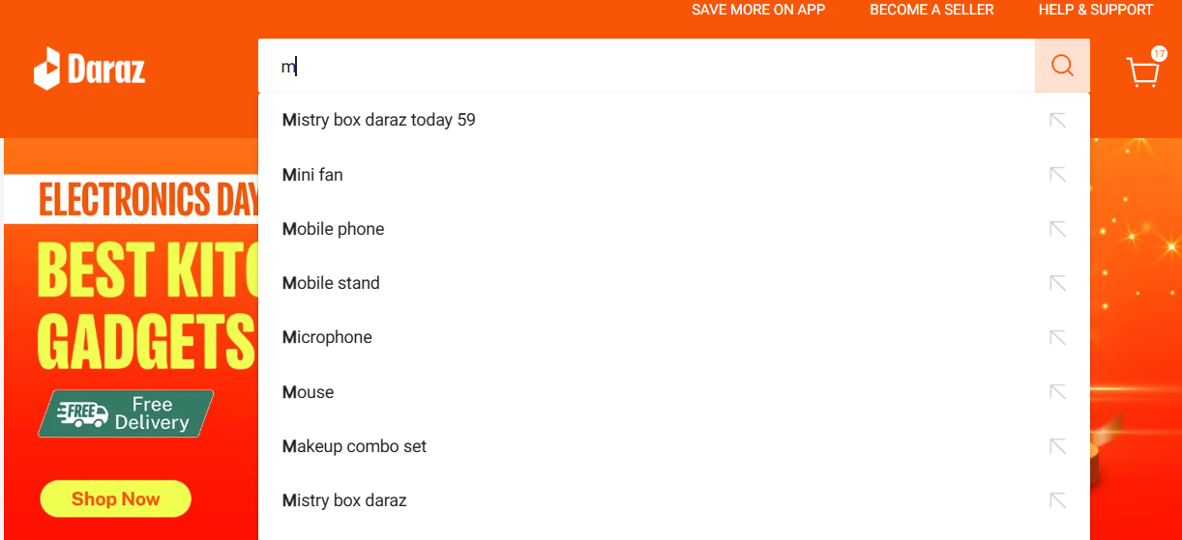
Search suggestions and auto-complete save users time and make frequently used products easy to find.

4. Screenshots Analysis

Good Examples
- Consistency in Bomepage Branding
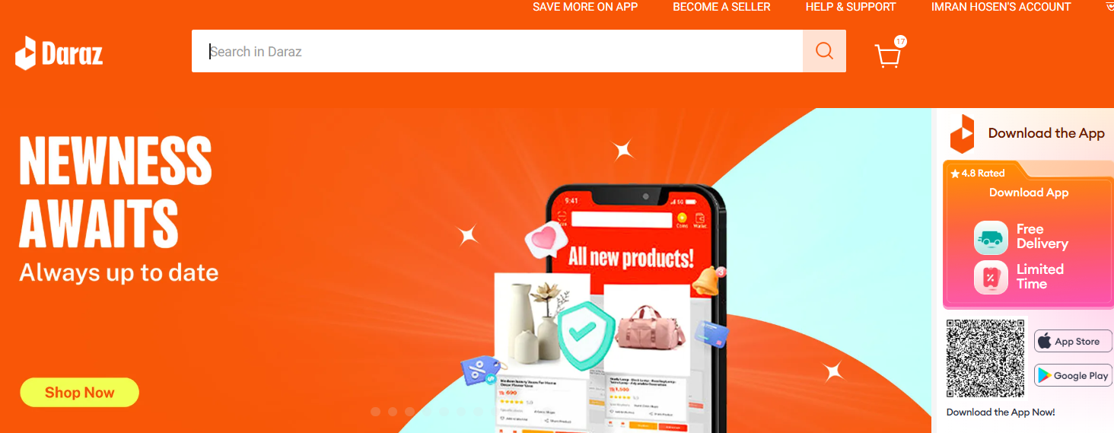
The top navigation bar on the Daraz website homepage serves as the main gateway for users. Here, categories like electronics, fashion, groceries, home decor, etc. are clearly separated. Such a consistent category layout quickly leads the user to the right section without confusing them. This is a strong aspect according to Shneiderman's "Strive for Consistency" rule.

- Responsive Design Across Devices
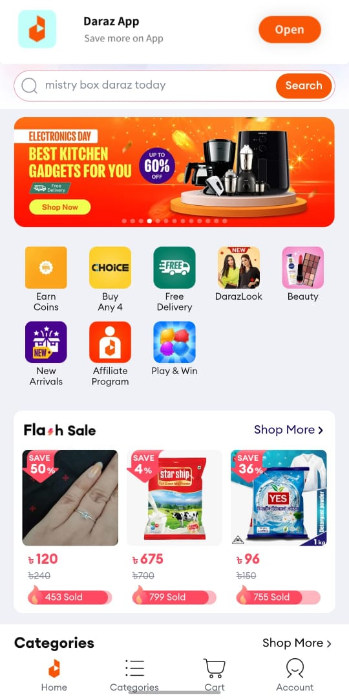
The Daraz site has a smart setup. It works well on phones, tablets, laptops, and desktops. Its menus, search bar, and item show shift well to fit any device. This makes it smooth and easy for any user.
- Secure Payment Gateway
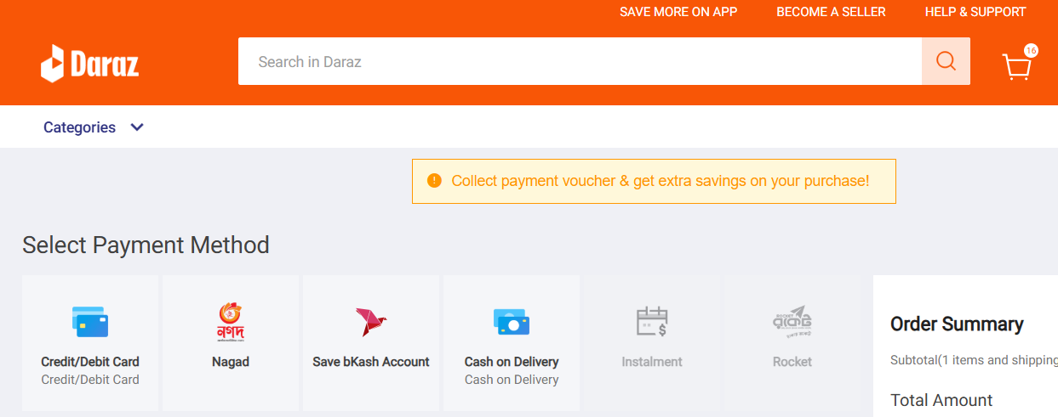
Daraz offers a variety of secure payment options (card, mobile banking, cash on delivery). Each option has clear labeling and visual icons, which creates trust for the user. This is a reflection of the Error Prevention and User Satisfaction policy.

Bad Examples
- Additional Promotional Banners
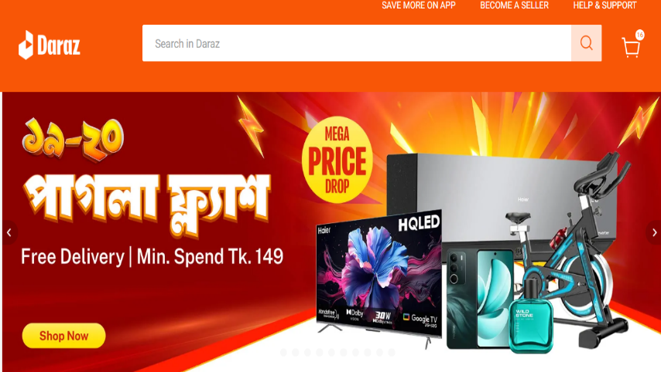




Too many promotional banners on the homepage break the user's attention. Instead of browsing the product, the user is pushed towards unnecessary ads and offers. This increases the cognitive load and the user has trouble finding what he wants quickly.
- Unclear Product Description
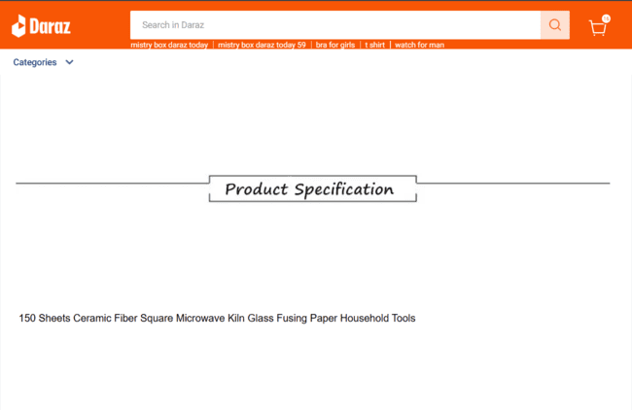
Things such as specs, promises, times for shipping, and guides are often not in the product info part. This lack of clear facts makes the buyer unsure and worried. It gets hard for them to pick what to buy.

- Complicated Return Process
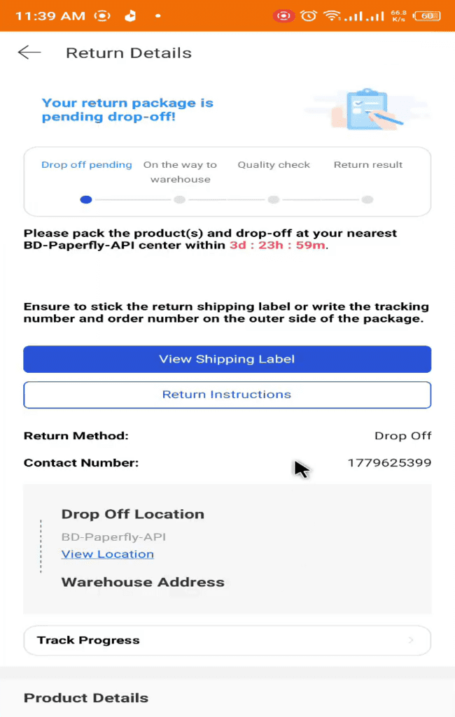

Daraz's return page needs you to log in, pick a reason, upload a photo, and more. These many steps can make users mad. Many folks stop the return work halfway. This spoils how they feel about the site.

5. Conclusion
I analyzed the structure and user interface of my chosen website, Daraz. First, I discussed how the website structure is arranged and how the subpages are connected to each other. Then, I evaluated the interface design using Shneiderman's eight golden principles, highlighting the website's strengths as well as some limitations.
From what I see, the website has good parts like its quick design, clear layout, search tool, and easy way to move around, all of which make it better for users. But there are also some problems. There are too many ads, unclear product info, and a complex return policy that may make things hard for shoppers.
In conclusion, I can say that although the Daraz website is basically user-friendly and effective, there is room for improvement in some areas. If these weaknesses are addressed by following the right principles, it can provide a better user experience.

6. Recommendations
1. Artificial Intelligence (AI) Integration: AI-based chatbots will make it feasible to offer immediate support, examine user behavior to make tailored suggestions, and enhance the general client experience.
2. Increasing website loading speed: Caching, server optimization, and compressed images must all be used to shorten the loading time of websites.
3. Improving product descriptions: A lot of products lack sufficient information. User confidence will rise with the addition of thorough technical specifications, reviews, and visual content.
4. Simplifying the return process: The existing return procedure is a little convoluted and drawn out. Users can finish their returns more quickly and easily if it is made simple step-by-step.
5. Improving the personalized recommendation system: Users will have a better buying time if they get clearer advice based on what they have looked at and bought before.
6. Improved Live Chat Support: Quick replies, good help from staff, and help all day and night will make users happier.

7. Recommendations
- Dix, A., Finlay, J., Abowd, G.D. and Beale, R., 2004. Human–Computer Interaction. 3rd ed. Pearson Education.
- Daraz, 2025. Daraz Online Shopping. Available at: https://www.daraz.com.bd/#? [Accessed 18 August 2025].

- Russell, J., 2018. Alibaba buys Rocket Internet’s Daraz to expand its e-commerce empire into South Asia. TechCrunch. Available at: https://techcrunch.com/ [Accessed 18 August 2025].
- The Daily Star, 2015. Daraz officially starts in Bangladesh. The Daily Star. Available at: https://www.thedailystar.net/ [Accessed 18 August 2025].

